CIS 5400: Mobile Application Programming

Project 1

JQuery

By: Bernice Templeman

09/13/2015

Btempleman2015@my.fit.edu

**Instructions:**

Create a project using JQuery and some of the simple HTML 5 widgets such as

* drop down menu,
* text box,
* list,
* etc.

You can incorporate mobile device functionality but it is not necessary of this project.

Provide several screen shots of your application running in a word document

with an explanation of what it does.

**Project 1**

I created a simple JQuery Mobile page with a

* header
* drop down menu,
* text box (dialog box),
* list, and
* link to first or second page.

The first page contains a drop down menu where you can select a recipe.

There is also a link to click on to go to Page 2.

**Simple page** explanation via: <http://www.w3schools.com/jquerymobile/jquerymobile_pages.asp>

* The data-role="page" is the page displayed in the browser
* The data-role="header" creates a toolbar at the top of the page (often used for title or search buttons)
* The data-role="main" defines the content of the page, like text, images, buttons, forms, etc.
* The "ui-content" class adds extra padding and margin inside the page content
* Inside these containers, you can add any HTML elements - paragraphs, images, headings, lists, etc.

**Page 1:**

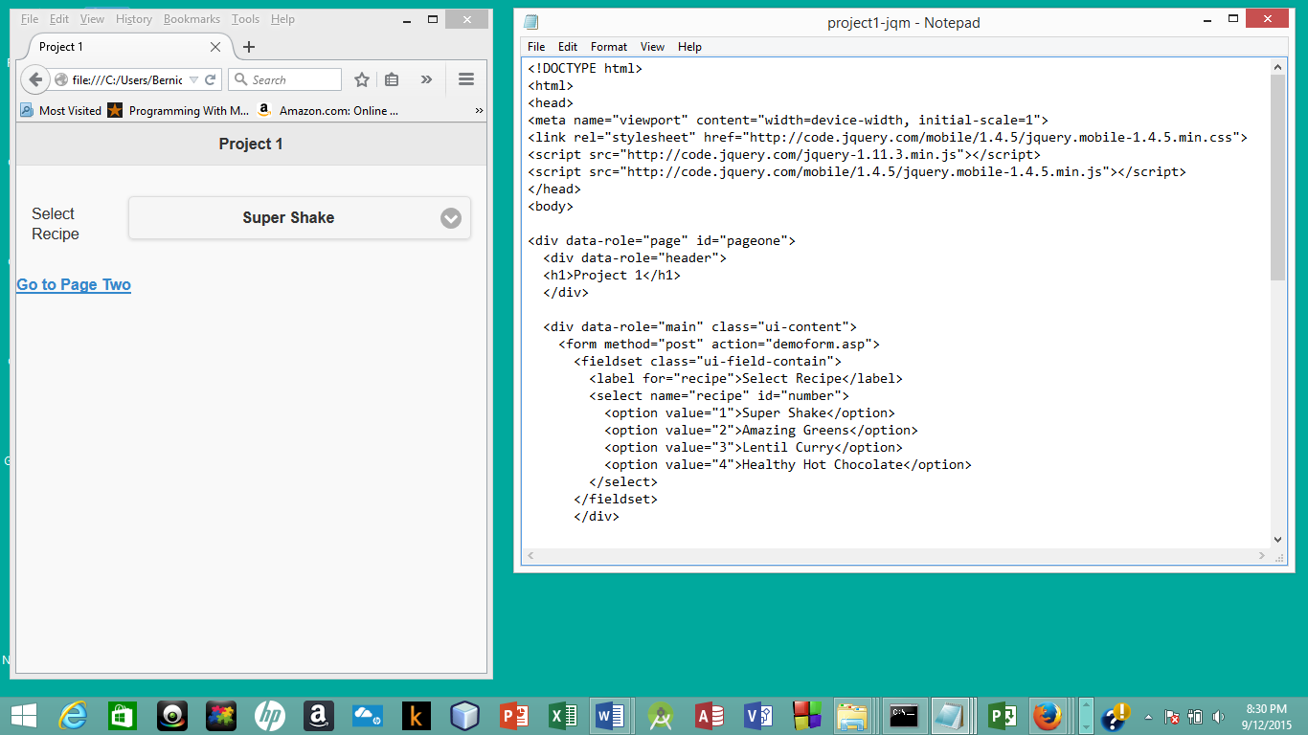

The drop down menu contains several Recipe names you can select.

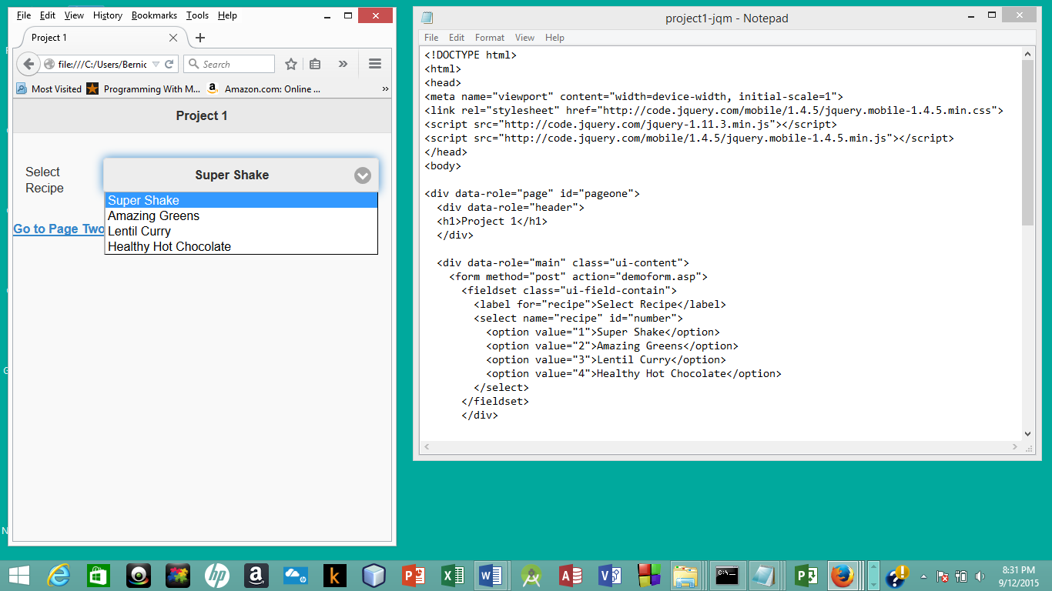

**Adding Pages:**

**“**In jQuery Mobile, you can create multiple pages in a single HTML file.

Separate each page with a unique id and use the href attribute to link between them:”

**Page 2:**

Contains:

List: list of recipe ingredients

Text Box: to enter name

Rating Box: to rate the recipe

Link: to go back to Page one

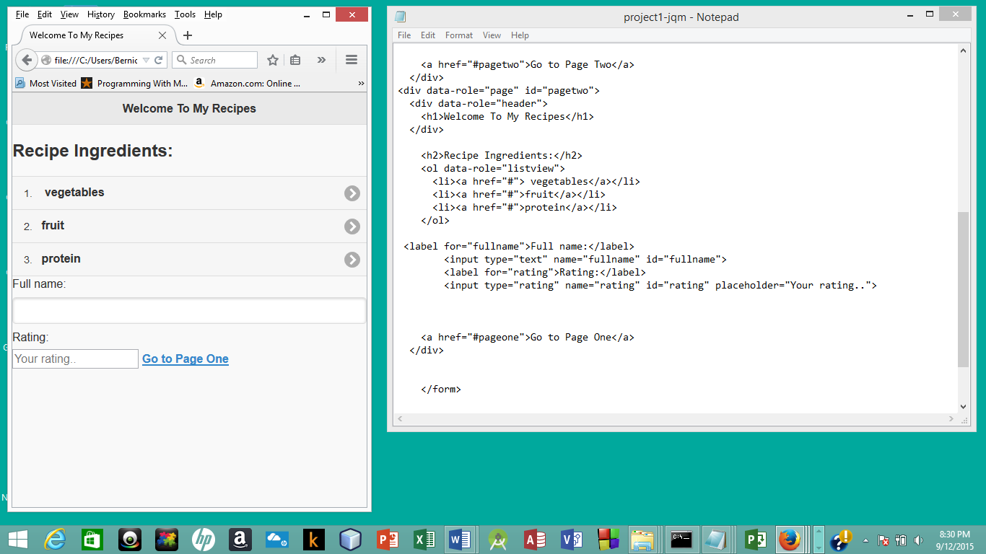

**Future Enhancements:**

Additional pages could be displayed when the user selects a recipe on the first page.

(or same page displays different ingredients based on recipe selected on page 1)

Maybe by using events and/or saving data. Could also add pictures.